City of Westminster: Freight, Servicing and Delivery (FSD) – Strategy and Action Plan
Stakeholder Questionnaire
Overview
WSP has been commissioned by Westminster City Council to develop a Freight, Servicing and Delivery (FSD) Strategy and supporting Action Plan.
The Strategy and Action Plan will focus on two primary objectives:
- Helping the City of Westminster become carbon neutral by 2040; and
- Reducing the number of Killed and Serious Injury collisions that involve pedestrians and cyclists with all motorised vehicles; including delivery and servicing vehicles.
The Strategy and Action Plan will also aim to support business resilience, reduce operating costs, reduce congestion and vehicle emissions, loading and unloading noise on the street and wider environmental impacts to provide a future vision for freight, servicing and delivery activity for the City of Westminster.
In order to develop a robust and relevant Strategy and Action Plan, it is important to engage with a wide range of stakeholders with an interest in freight movement, servicing and delivery activity within the City of Westminster.
These stakeholders range from businesses and institutions etc. located within Westminster to the companies that operate vehicle fleets to service those premises, residents who live within the City of Westminster and a host of other organisations that influence how freight, servicing and delivery activity serves our economy.
This questionnaire provides the opportunity for you to contribute to the development of the Strategy and Action Plan and help to shape how goods are moved and servicing is provided within the City of Westminster, now and in the future.
We are eager to hear your views on challenges, their impact, potential solutions and what Westminster City Council’s FSD Strategy and Action Plan should include.
We would be grateful if you would complete the short questionnaire below and return to WCC-FSD@wsp.com by Wednesday 26th August, 2020.
If you feel other colleagues in your organisation would be better suited to complete the questionnaire, please feel free to forward to them for review and return.
Before starting to complete the Questionnaire, please read and Questions and Answers below:

Questions and Answers
Why is Westminster City Council undertaking this work?
Westminster City Council understands the importance of efficient, economic, safe and sustainable movement of goods and services within its area. The Council must meet its carbon neutral target by 2040 and also ensure its roads and footways are safer for all users. The FSD Strategy and Action Plan will be designed to support these objectives, as well as ensuring residents, businesses and other organisations located within the City of Westminster can receive the goods and services they need to thrive economically.
What types of activity are covered under ‘freight, servicing and delivery’?
‘Freight, servicing and delivery’ is a wide-ranging term and covers all types of commercial vehicle activity, from parcel couriers to personal deliveries, waste and refuse collection, supermarket deliveries, food and non-food retail to commercial construction (including demolition and construction HGVs and mobile cranes).
Importantly, it also covers work done by, for example, service engineers repairing office equipment, facilities management teams refurbishing premises and shopfitters working on retail outlets. It also covers those visits by traders, personal services and building services provided to residential properties.
Which areas within Westminster are to be covered by the Strategy and Action Plan?
The FSD Strategy and Action Plan will cover the whole of the City of Westminster (as shown in the map below). Where initiatives have already been developed in specific locations, these will be taken into account in the development of the whole area-wide Strategy and Action Plan.
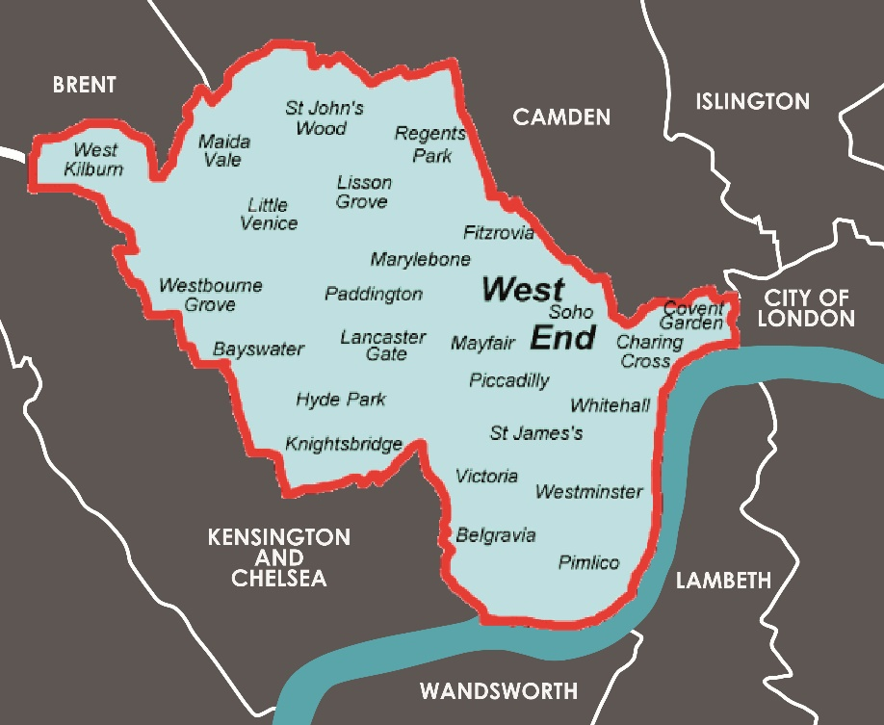
Map: City of Westminster and neighbouring boroughs

Why is my input valuable?
It is important that we consider the views of a diverse range of stakeholders and the engagement list has been developed accordingly. You/your organisation has been identified as having an important contribution to make.
Will my responses be made public?
A list of stakeholder organisations engaged during the development of the FSD Strategy and Action Plan will be included in the final document produced but individuals will not be named. The source of any views presented in our reporting will neither explicitly, nor implicitly, be identifiable to one particular stakeholder (either the organisation or a named individual), unless written permission is provided.
What are the next steps?
In parallel to this stakeholder engagement phase, we are assembling supporting documents specific to Westminster’s dense urban characteristics and also identifying best practice case study examples which are relevant to the City of Westminster setting.
Once we have received and analysed the survey responses from stakeholders, we will begin to draft the Strategy and Action Plan. This work is due to complete by the end of August, 2020.
What if I’d like to be involved in the subsequent work?
That would be great. Please contact those named below to confirm your interest and willingness to participate in further stages of the work.
Who do I contact if I have further queries about this activity?
Should you have any questions please contact the project team through WCC-FSD@wsp.com or the Westminster City Council lead, Barry Smith, at bsmith@westminster.gov.uk .
Questionnaire
Please feel free to expand the boxes below to accommodate more detailed responses.
- Please describe your organisation, its activities and interests specifically relating to freight, servicing and deliveries in the City of Westminster:

Response

- Considering freight, servicing and delivery activity within the City of Westminster, what challenges do you encounter and where?

Response

- How do those challenges impact your organisation?

Response

- What measures do you take to counter those challenges and how effective are they?

Response

- What measures would you consider to reduce the number of freight, servicing and delivery movements within the City of Westminster?

Response

- How effective do you think using alternative modes (like eCargo bike, eBuggy or EV DVLA licenced trike) would be in tackling the challenges you identified above?

Response

- What role could re-timing of freight, servicing and delivery activity play within the City of Westminster in the future?

Response

- How can Westminster City Council help in accommodating more efficient, economic, safe and sustainable freight, servicing and delivery, now and in the future?

Response

- What actions would you like to see in the outputs from this work?

Response

- If you are an operator do you have confirmed orders to buy or lease any Zero Emission vehicles for operation in Central London in the near future, say within two years?

Response

- Do you have any other comments that you think will be of value to the development of the FSD Strategy and Action Plan?

Response

Thank you for taking the time to complete the Questionnaire. Your input is much appreciated.

